Book Search using API

(Google Books API)

Submitted in partial fulfillment for the mini project submitted

By

Roll No:

For the subject

Cloud Computing Laboratory



Computer Engineering Department

Rizvi College of Engineering

2017-2018

**CERTIFICATE**

This is to certify that the project entitled **“**Google Books API**”** is a bonafide work of “**” (Roll No: )** submitted in partial fulfillment of the requirement for the mini project in the subject of Cloud Computing Laboratory.

Prof. Shiburaj P.

Guide

Prof. Shiburaj P. Dr. Varsha Shah

Head of Department Principal

**ABSTRACT**

The website offers book details to the user based on the searched text using the Application program interface (API) provided by Google books API. The website offers a simple search box wherein the user enters the name of the book that he/she wishes to find. The website then uses the API to search for the matching results and lists the numerous books available on the website along with their details such as authors name, published date, publishers name, price, rating, description and ISBN number. The details mentioned above helps the user to know about the book. The user can then select the book of his/her choice by clicking on the book name provided along with the result.

Keywords: Application Programming Interface (API), Book search.

Index

|  |  |  |
| --- | --- | --- |
| Sr. No | Title | Page No |
| 1. | Chapter 1: Introduction | 5 |
| 2. | Chapter 2: Implementation | 7 |
| 3. | Chapter 3: Results and Output | 8 |
| 4. | References | 10 |
|  | Acknowledgement | 11 |

**Chapter 1**

**Introduction**

Google books is a Website which uses an API to search for books of different categories from a very large and ever-expanding database. It works by making a URL call to a website which returns the details in JSON format which is then converted into a much more easily readable format.

**Application Programming Interface (API):**

In computer programming, an application programming interface (API) is a set of subroutine definitions, protocols, and tools for building application software. In general terms, it is a set of clearly defined methods of communication between various software components. A good API makes it easier to develop a computer program by providing all the building blocks, which are then put together by the programmer. An API may be for a web-based system, operating system, database system, and computer hardware or software library. An API specification can take many forms, but often includes specifications for routines, data structures, object classes, variables or remote calls. POSIX, Windows API and ASPI are examples of different forms of APIs. Documentation for the API is usually provided to facilitate usage.

**Web API**

A Web API is an application programming interface for either a web server or a web browser. It is a web development concept, usually limited to a web application's client-side (including any web frameworks being used), and thus usually does not include web server or browser implementation details such as SAPIs or APIs unless publicly accessible by a remote web application.

Computers make a lot of things easier, especially tasks that involve collecting and sorting through tons of data. Let’s say you wanted to know how many times a particular business partner submitted invoices to your company. You could feasibly go into your company’s invoice records, scan the “from” data input, and print each invoice individually for your audit.

On the other hand, if all invoices were uploaded to a central database, you could write a simple program that accesses that database and finds all the instances of the partner’s name. This would take much less time and be much more accurate.

**Architecture of an API**

APIs consist of three parts:

1. User: the person who makes a request
2. Client: the computer that sends the request to the server
3. Server: the computer that responds to the request

Someone will build the server first, since it acquires and holds data. Once that server is running, programmers publish documentation, including the endpoints where specific data can be found. This documentation tells outside programmers the structure of the data on the server. An outside user can then query (or search) the data on the server or build a program that runs searches on the database and transforms that information into a different, usable format.

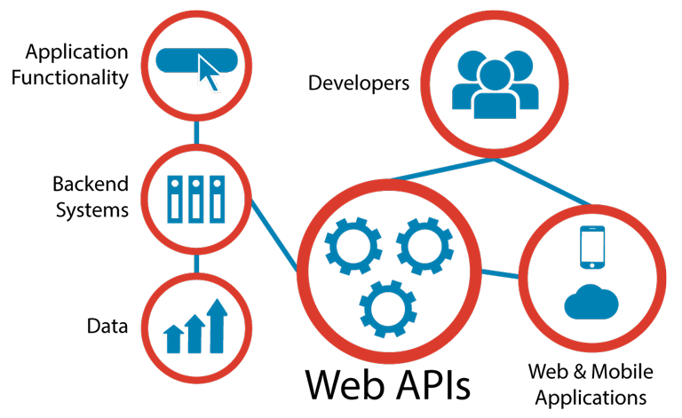

Fig. 1- How Web APIs function

**Examples of a WebAPI**

ProgrammableWeb, a site that tracks more than 15,500 APIs, lists Google Maps, Twitter, YouTube, Flickr and Amazon Product Advertising as some of the most popular APIs. The following list contains several examples of popular APIs:

1. Google Maps API: Google Maps APIs lets developers embed Google Maps on webpages using a JavaScript or Flash interface. The Google Maps API is designed to work on mobile devices and desktop browsers.

2. YouTube APIs: YouTube API: Google's APIs lets developers integrate YouTube videos and functionality into websites or applications. YouTube APIs include the YouTube Analytics API, YouTube Data API, YouTube Live Streaming API, YouTube Player APIs and others.

3. Flickr API: The Flickr API is used by developers to access the Flick photo sharing community data. The Flickr API consists of a set of callable methods, and some API endpoints.

4. Twitter APIs: Twitter offers two APIs. The REST API allows developers to access core twitter data and the Search API provides methods for developers to interact with Twitter Search and trends data.

5. Amazon Product Advertising API: Amazon's Product Advertising API gives developers access to Amazon's product selection and discovery functionality to advertise Amazon products to monetize a website.

**Chapter 2**

**Implementation**

**Implementation of Google Books API:**

Here we call the API from the API provider https://www.googleapis.com/books/v1/volumes

1. A request is sent to the API in the form.

https://www.googleapis.com/books/v1/volumes?q={search terms}&key={API key}

1. The API_KEY is the unique key we get when we register for that API. It is used so that unauthorised request to the server are not made.
2. The call returns parameters using cURL get request.
3. We get these parameters in JSON format. Then they are converted into readable format and then displayed in a tabular format.

**Chapter 3**

**Results and Output**

1. **Website home page and search bar**

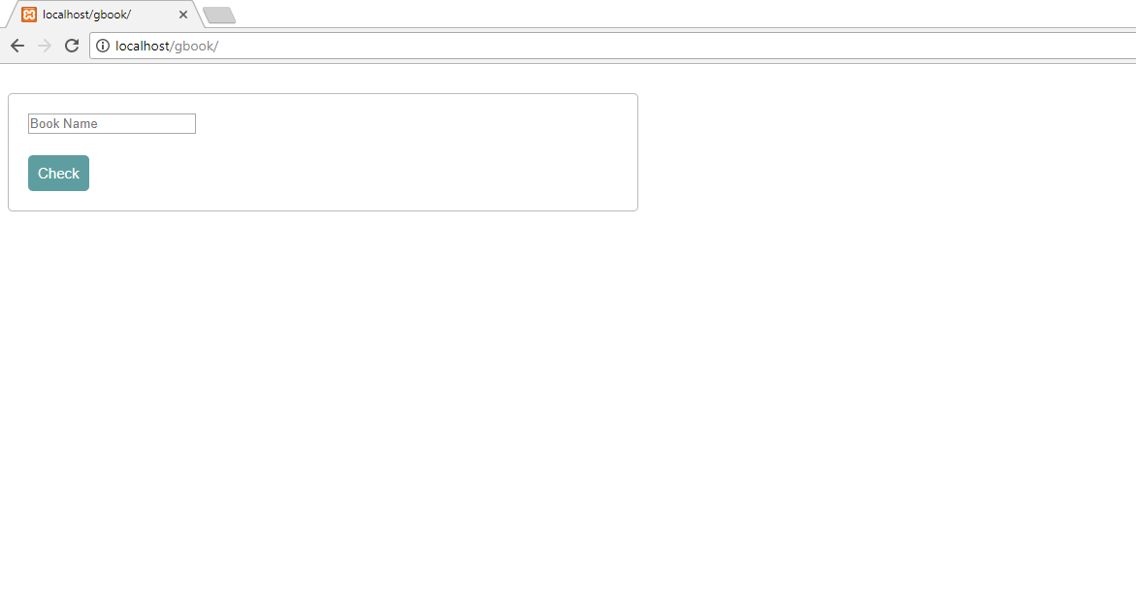

1. **Displaying Search results**

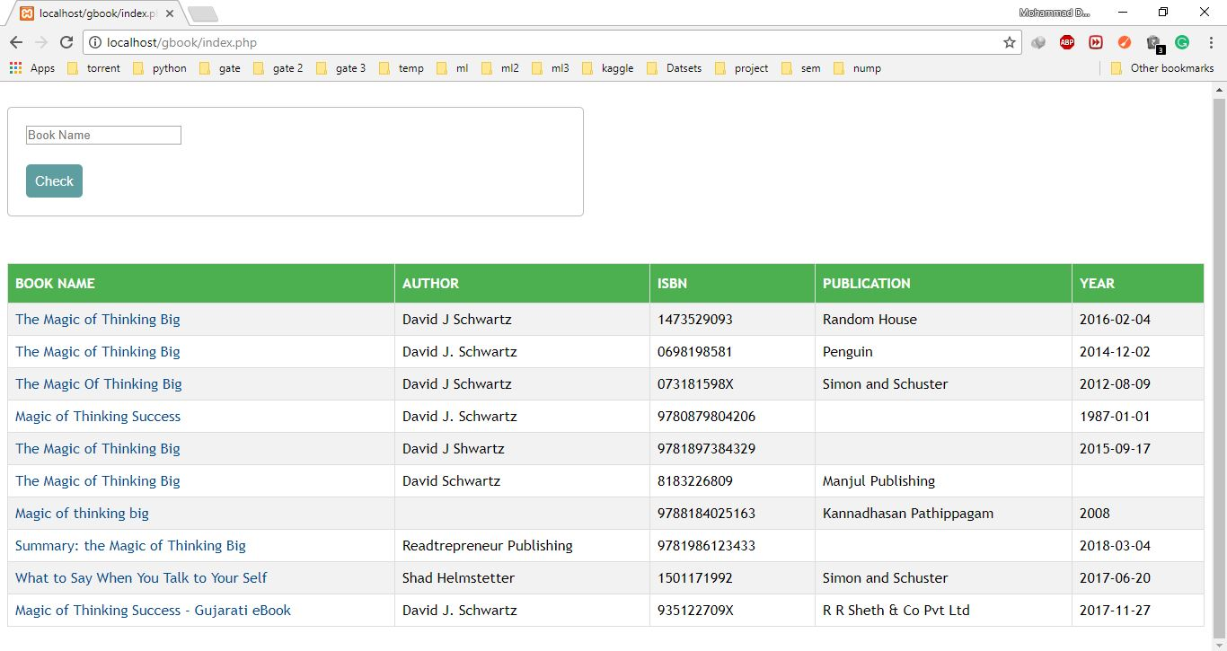

1. **Book details after clicking on book name.**

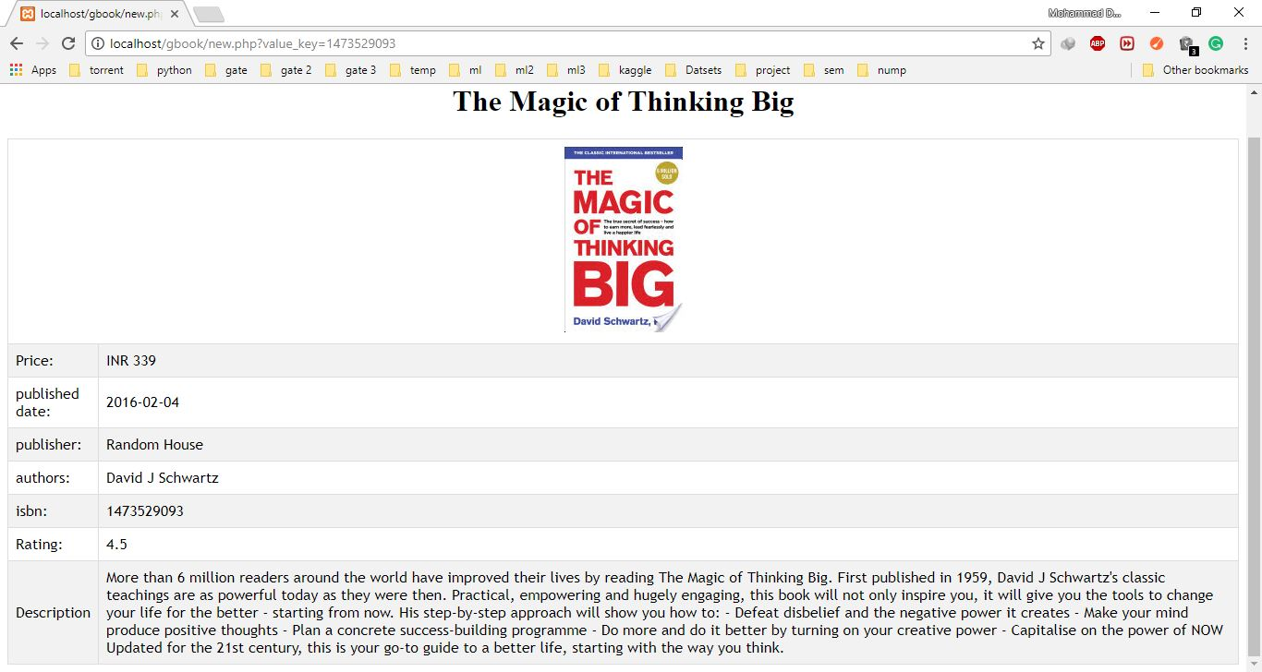

**Conclusion:**

Hence we have studied and made use of a Web API in a website to search for Book.

**References**

**Website,**

[1] Google Books API

https://www.googleapis.com/books/v1/volumes

[2] Microsoft Developers Network – Using API with PHP

<https://msdn.microsoft.com/en-us/library/dd440739.aspx>

[3] ProgrammableWeb

<https://www.programmableweb.com/category/all/apis>

[4] Learn how to code

<https://learn.shayhowe.com/advanced-html-css/>

**Acknowledgement**

I take this opportunity to express my profound gratitude and deep regards to my guide **Professor Shiburaj Pappu** for his guidance, monitoring and constant encouragement throughout the course and the project.